NHDGeodatabase State-wide Coverage Personal GeoDatabase Exports

A Personal GeoDatabase (.pgdb) export of the state contained in the NHD Geodatabase Hydrography Feature Dataset as of December, 2004 was produced from an ArcSDE 8.3 SDE instance installed on an Oracle 9i (Release 9.2.0.4.0) Database on a Sun Microsystems server (SunOS 5.9).
The .pgdb is accompanied by an XMI file containing the GeoDatabase schema. The XMI file (Sept2004.xml) must exist in the same directory with the accompanying dtd file (uml.dtd). The XMI file can then be loaded into an existing ArcSDE instance from ArcCatalog with the following steps:

1. ArcCatalog -> Tools -> Customize -> Commands
Select Categories -> Case Tools
Select Commands -> Schema Wizard
Drop and Drag the Schema Wizard onto the ArcCatalog tool bar.

2. From a Database connection to the SDE instance as the owner of the NHD data, select the Schema Wizard. Browse to the Sept2004.xml file and select it. In the next window, select ‘Use values from previous run.’ In the following window, start at the top of the list of feature datasets, feature classes and tables, and select the Hydrography feature dataset. Select ‘Properties’, check ‘Show Details’, and Edit the Spatial Reference Properties as shown below for:
1. Geographic Coordinate System
GCS_North_American_1983 (NAD83)
2. X/Y Domain:
Min X: -200 Max X: -56.8344238888883
Min Y: 0 Max Y: 143.1655761111112
3. M Domain:
Min: 0 Max: 2147483.645
Precision: 1000
4. Z Domain:
Min: -10000 Max: 204748.3645
Precision: 10000

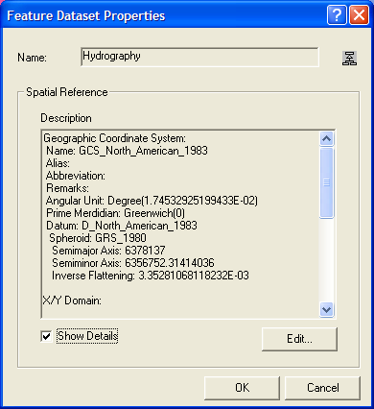
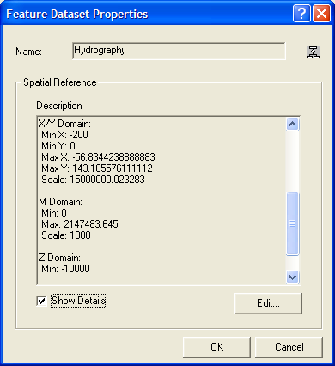

Select the first feature class (NHDPoint) under the Hyrography feature dataset and select Properties. The Spatial index grid sizes and ArcSDE Configuration Keyword must be set for each feature dataset. Spatial index grid sizes suggested for the NHD Data are shown below:

NHD Feature Class Spatial Index GRID
NHD.SHAPE.NHDPOINT <.3,0,0>
NHD.SHAPE.NHDLINE <1.5,0,0>
NHD.SHAPE.NHDFLOWLINE <.1,0,0>
NHD.SHAPE.NHDWATERBODY <.15,0,0>
NHD.SHAPE.NHDAREA <3,0,0>

Continue in this manner for the additional feature classes and feature dataset. For the associated tables, only the configuration keyword must be defined.

3. Once the schema has been defined and the feature datasets created, review the Schema summary and select ‘Finish’.
4. The NHD data may then be imported from the .pgdb. For each feature class and table, select ‘Load Data’ to add the data into the existing schema via the Simple Data Loader wizard.

